Smallest Even Multiple
Platform: Leetcode
Language: C
Module 2, Question 2

Problem Link
https://leetcode.com/problems/smallest-even-multiple/description/

Problem Statement
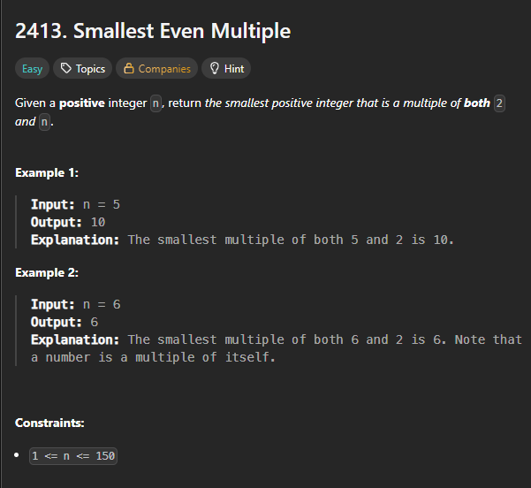

C Code
int smallestEvenMultiple(int n) {
if (n % 2 == 0) return n; // already even, so n is a multiple of both 2 and n
return n * 2; // odd: the smallest common multiple is 2n
}

Screenshot of Successful Submission



